**Requirement Analysis**

**Data Flow Diagram & User Stories**

|  |  |
| --- | --- |
| Date | 19 June 2025 |
| Team ID | LTVIP2025TMID48554 |
| Project Name | ShopSmart: Your Digital Grocery Store Experience |

**Data Flow Diagram (DFD) :**

A **Data Flow Diagram (DFD)** is a graphical representation of how data moves through a system. It shows the **flow of data between processes, external entities, and data stores** in a system without showing program logic or internal data structures.

**Why Use a DFD?**

* It provides a **clear overview** of how the system handles data.
* Useful for analyzing and designing the system architecture.
* Helps identify inputs, outputs, processes, and data storage in a system.

**Components in a DFD**

* **External Entities:** Represent users or systems that interact with the application.
* **Processes:** Represent tasks/functions performed by the system.
* **Data Stores:** Databases or storage that hold data.
* **Data Flows:** Arrows that show the movement of data between entities, processes, and stores.

**Example (Simplified Flow for ShopSmart):**

Customer --> [Login/Register] --> [Authentication Process] --> [User Database]

Customer --> [Browse Products] --> [Product Search Process] --> [Product Database]

Customer --> [Add to Cart] --> [Cart Process] --> [Cart Database]

Customer --> [Checkout] --> [Order Process] --> [Order Database]

Admin --> [Manage Products] --> [Product Management Process] --> [Product Database]

**Data Flow Diagram (DFD):**

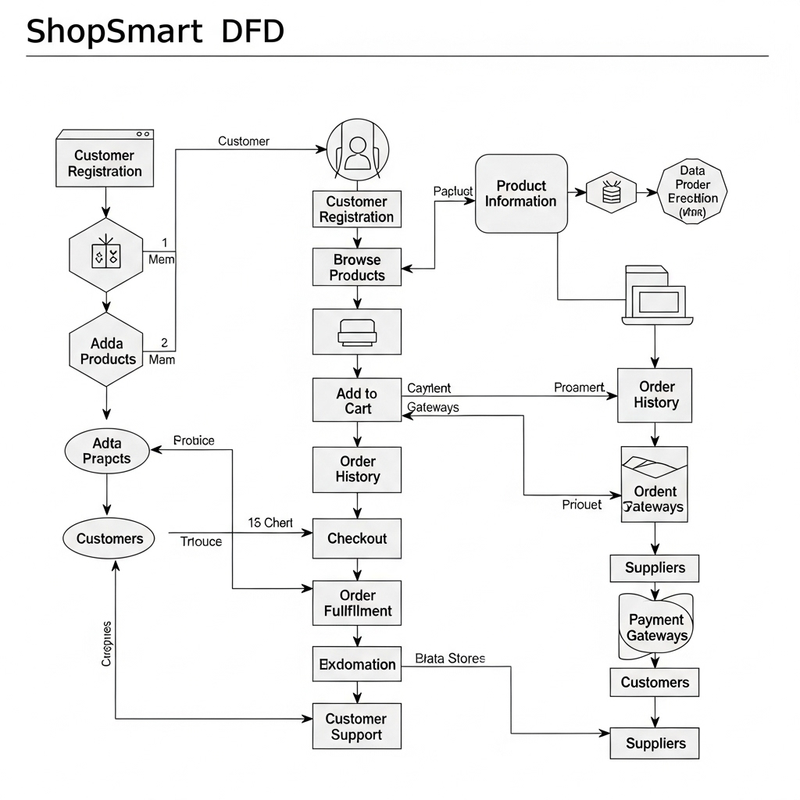

**User Stories Table:**

| **User Type** | **Functional Requirement (Epic)** | **User Story Number** | **User Story / Task** | **Acceptance Criteria** | **Priority** | **Release** |
| --- | --- | --- | --- | --- | --- | --- |
| Customer (Mobile user) | Registration | USN-1 | As a user, I can register for the application by entering my email, password, and confirming my password. | I can access my account / dashboard | High | Sprint-1 |
|  |  | USN-2 | As a user, I will receive a confirmation email once I have registered for the application. | I can receive a confirmation email & click confirm | High | Sprint-1 |
|  |  | USN-3 | As a user, I can register for the application through Facebook. | I can register & access the dashboard via Facebook | Low | Sprint-2 |
|  |  | USN-4 | As a user, I can register for the application through Gmail. | I can register & access via Gmail | Medium | Sprint-1 |
|  | Login | USN-5 | As a user, I can log into the application by entering my email & password. | I can access the system securely | High | Sprint-1 |
| Customer (Web user) | Product Search & Order | USN-6 | As a user, I can browse and search products using category and price filters. | I can view filtered product results | High | Sprint-2 |
|  |  | USN-7 | As a user, I can add products to my cart and adjust quantities. | My cart updates dynamically | High | Sprint-2 |
|  |  | USN-8 | As a user, I can place orders with a selected payment method. | I get a success message and confirmation email | High | Sprint-2 |
| Seller | Product Management | USN-9 | As a seller, I can log in to my dashboard and manage my product listings. | I can add/edit/delete products | High | Sprint-3 |
|  |  | USN-10 | As a seller, I can view and track customer orders. | I see a list of customer orders | Medium | Sprint-3 |
| Admin | Admin Dashboard | USN-11 | As an admin, I can approve or deactivate sellers. | I can manage seller status from dashboard | High | Sprint-3 |
|  |  | USN-12 | As an admin, I can manage product listings and user accounts. | I can add/edit/delete any products or users | High | Sprint-3 |